Sales:
Secondary website with used inventory from the 3 locations that is hosted replit.

1. Olympic Hyundai Vancouver, Boundary Hyundai Vancouver, and Kia Vancouver inventory grid that pulls year, make, model, all necessary info from all three of their used websites. .
(automatic scraper that looks at the website and carguru to gather all the data onto a dtabase and then the database updates the websites.)
1a. Sticky bar that asks for “credit score”, “downpayment” and adjusts the interest rate and payments based on this data shown on the vehicle view.
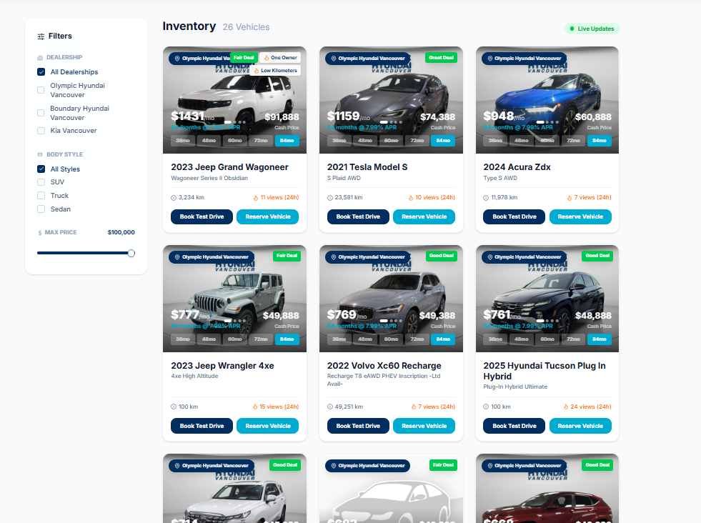
1b. We don’t need live updates, we will just have it run every day at midnight (through n8n scraper or something else, you tell me).
1c. in the inventory view of all the cars, it needs to show a badge of which dealership, the payments, term selction, the “no accidents” or “one owner” (That info is scraped from carguru or website), as well as the “XX views in last 24 hours”,
1d- Underneath the picture but still on the stock card, it will show the CTA “Book Test Drive” and “Reserve Vehicle” which opens the dynamic page of the vehicle and the chat opens up right away based on the CTA they clicked.
1e- The pricing needs to be 100% correct, the images need to be able to scroll from the grid view.
1e- The ability to scroll across the images from the grid view. The images for the vehicle must only be of that vehicle.
1f- The filters

///

2. Dynamic Vehicle Page - The vehicle stock card that when a certain vehicle is clicked opens up a dynamic page with all the vehicle information. It has all the cta that the best websites have (“Get Approved”, “Value My Trade-in”, “Book Test Drive” and “Reserve Vehicle” or “Get Pre-Approved”). Any CTA they click, it triggers a unique message in the chat bubble that is powered through AI that helps nurture the lead.
2a- Tracking for Google shop, youtube, and Instagram remarketing.
2b- Connect to Google gemini veo to create videos based on the pictures for remarketing.
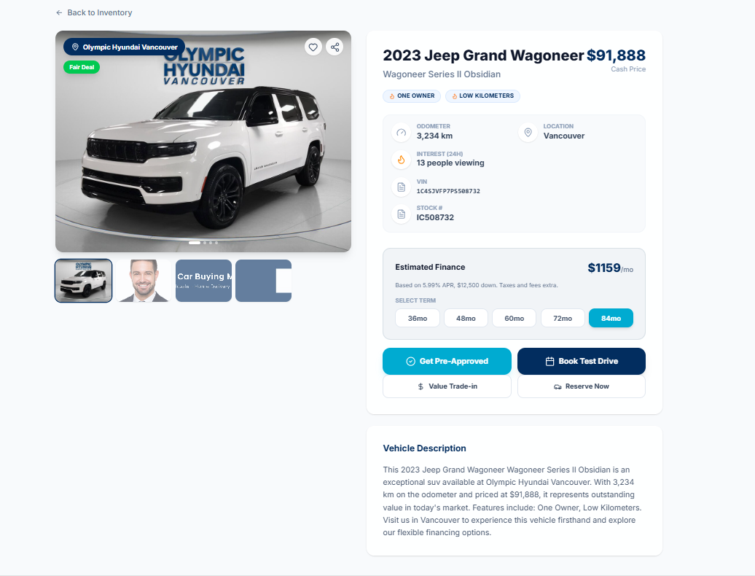
The images need to pull all images of the vehicle.
3. There needs to be a master user log-in, sales manager login, and a sales person log-in with different account access.
3a. The master user can adjust the settings here (credit score needed for certain interest rates, which model years can get approved for certain terms (example, a 2017 cant get approved on 84 months but a 2022 can). Alsosee all other account access. Also, the master user can select which vehicles that have the remarketing set-up for. They can select up to 20 vehicles that will have remarketing set-up for and can prioritize the budget.
3b. A sales person connects their facebook accounts, where they can connect up to 5 facebook accounts. For each facebook account, they preselect a template where they can input dynamicVariables into the facebook marketplace ad templates. After saving the template, they can see all the vehicles from the inventory grid that is broken down into year, make, model, and dealership its located at. They select the order in which it will post (1,2…45). The visual they can see is the facebook page connections (max 5), after clicking on it, it shows information underneath it for which vehicles to post, and the template with the dynamic variables. At the bottom of the list, there is the template copy that they can edit. When they click on one of the vehicles in the list, a drop down shows the filled out template for their review. Any leads that come through the facebook pages, it is connected to the ghl ai that will nurture the lead, follow-up with them, and just handle all incoming leads. It needs to be connected to all the pages for all the sales guys so will need to be authenticated somehow to connect to facebook marketplace and facebook pages.
Also, they can choose a time buffer between posts, and the starting time. Example, start at 9am and be 3 hours between posts.
3c. The sales manager can see a price comparison tool. For example, this will replace Vauto. The sales manager can input a vin, it will decode it down to year, make, model, trim, find all similar vehicles within a selectable distance (100km, 250km, 500km, 1000km, national) and be able to select additional years and additional trims, just like Autotrader. It also needs to tell me how long its been in stock (maybe carguru is better for data). This needs to be executed only when the manager clicks enter.
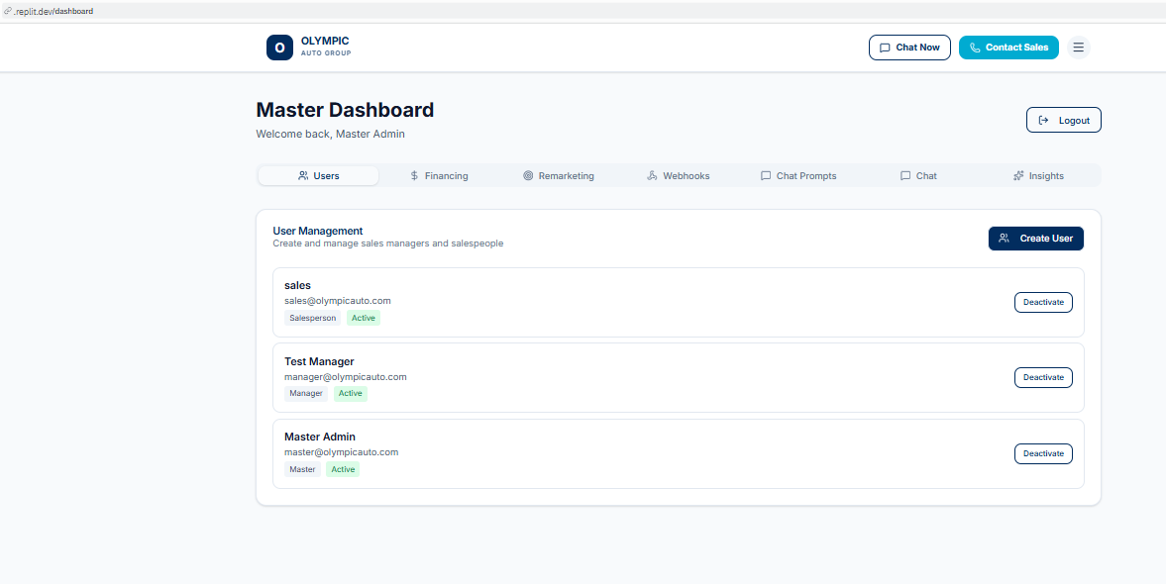
Master can control the users that log-in to this account, set the financing terms, interest rates, and length. Webhooks is done via the super admin for this master user account. The chat prompts, chat, and isights all look good as long as it truly updates the ai logic through the connection to chatgpt. .
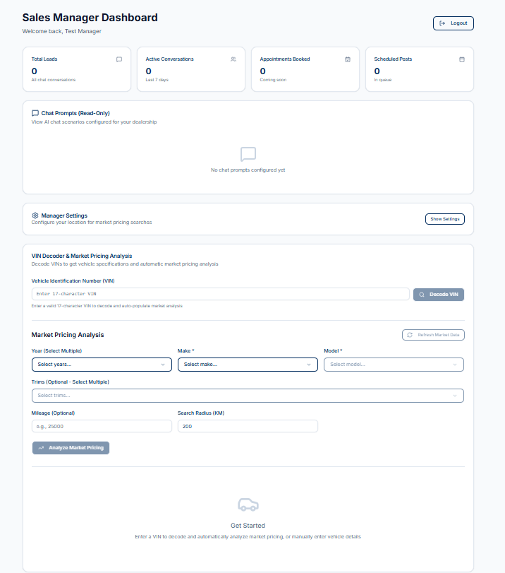
Sales manager dashboard needs the selector for the sections like the master user does, with “Market Data” as one option, Chat Prompts as other that gives same results from master. The master is only one that can edit the prompts but sales manager can read it. Settings is another tab.
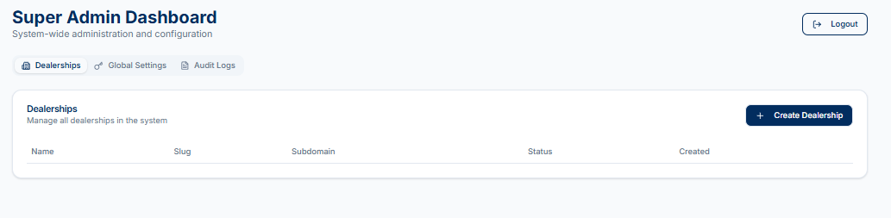
Super admin can add all of this information, including the carguru link to inventory and used inventory webpage. This needs to 100% work that when a user is created, they get a log-in.
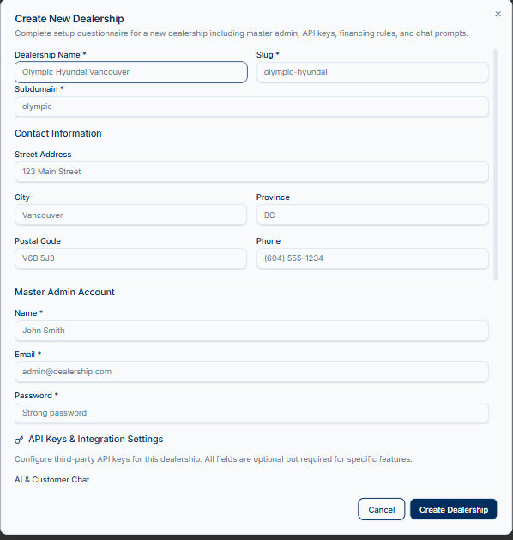
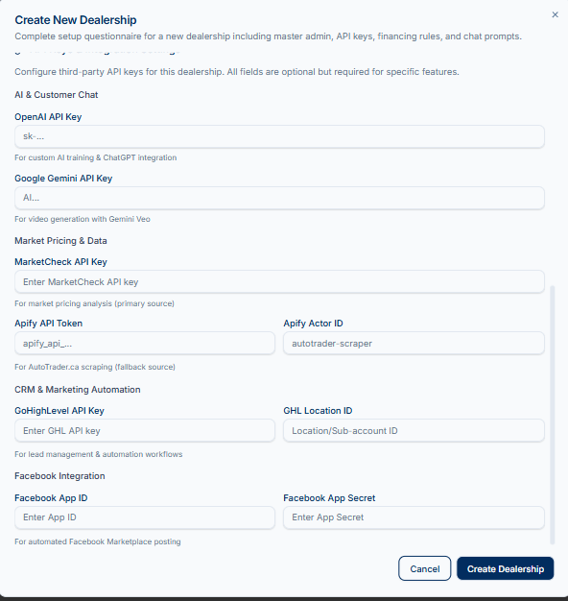
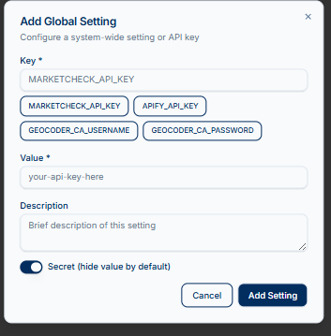
4- PBS sends customer info that has been more than 14 days to our GHL CRM, where a follow-up conversation happens via ai in ghl through sms or email. There will be a dashboard in the sales manager and master log-in showing all the leads that have come in via facebook marketplace and pbs connections.
5- Our company will also create facebook pages, that all the leads will push to pbs as a lead after we got their phone number, email, and name. The conversation needs to be summarized and based on the CTA, that’s the type of lead sent. We will be able to connect to the same sales person functions from a master user account.

I build that next, or would you like to work on something else?
Add a "dark mode" toggle for user interface.Implement real-time notifications for new leads and scheduled posts.Add an interactive calendar view for scheduled social media posts.Integrate with a popular CRM system for lead management.Develop a mobile-responsive interface for the manager dashboard.

